Cancer incidents in relation to superfund sites

Is there a higher incident of cancer in counties that contain a Superfund site? This is the main research question that was answered. The hypothesis generated is; Due to the negative environment impact of superfund sites, the expectation is that cancer rates will be higher in the counties that contain Superfund site designations.

The Results: When scatter plots were applied for number of superfund sites vs incident rates, from a visualization point of view, it varied in distribution in the sense that the scatter plots were not aggregated in the location of high superfund sites here is a classic illustration of such a case.

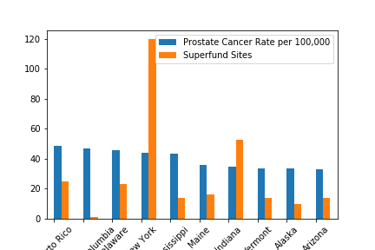

Hypothesis Rejection: According to the data displayed above, it makes a good case for the hypothesis to be rejected. For instance, in New York, this state has the highest number of superfund sites and so it was expected that it would have the highest incidents of prostate cancer rate. However, upon close examination of the data, Puerto Rico has the highest prostate cancer rate yet fewer superfund sites. When utilizing Chi-square analysis there was very little correlation in lung, and colon cancer the correlation coefficient is practically at zero for Prostate and Breast cancer it was at 11 and 13 percent respectively.